**3.3 Properties of Functions**

**A function is even** if: it’s symmetric with the ___________________________

To test algebraically you see if 



**A function is odd** if: it’s symmetric with the ___________________________

To test algebraically you see if 



If a function isn’t even or odd, then it’s _____________________

(Functions can only be even or odd. Never both)

~~~~~~~~~~~~~~~~~~~~~~~~~~~~~~~~~~~~~~~

How to test for Even/Odd Algebraically:







$$f\left(x\right)= x^{2}-5$$

$$g\left(x\right)=x^{3}-1$$

$$h\left(x\right)=5x^{3}-x$$

The Local minimum value is/are __________ at the number(s) x= _____:

The Local maximum value is/are __________ at the number(s) x=______:

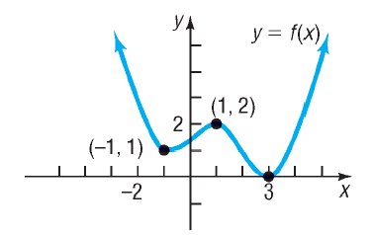









(e) List the intervals on which *f* is **increasing**.

(f) List the intervals on which *f* is **decreasing**.

Using your “Graphing Utility”

$$f\left(x\right)=2x^{3}-3x+1 (-2, 2)$$

1. Find any local maximum/minimum
2. Determine where f is increasing/ decreasing

**Average Rate of Change:**

The average rate of change from a to b is defined as:

Find the average rate of change of $f\left(x\right)=3x^{2}$

1. From 1 to 3
2. From 1 to 7

**Slope of the Secant Line:**

The average rate of change of a function from _____to _____ equals the _________ of the secant line containing the two points (_____,_____) and (______, _______) on its graph.

$$g\left(x\right)=3x^{2}-2x+3$$

1. Find the average rate of change of g from -2 to 1.
2. Find an equation of the secant line containing (-2, g(-2)) and (1, g(1)).

Difference Quotient*: the bridge between Algebra (slope) and Calculus (derivative)*

$$m_{sec}=\frac{f\left(x+h\right)-f(x)}{h} h≠0$$

$$f\left(x\right)=2x^{2}-3x+1$$

1. Express the slope of the secant line in each function in terms of x and h.
2. Find msec for h=0.5, 0.1, and 0.01 at x=1. What does msec approach as x approaches 0?
3. Find the equation for the secant line at x=1 with h=0.01.
4. Use a graphing utility to graph f and the secant line found in part c on the same viewing window.