Math 1050- 5.1 Notes:
Polynomial Function:

Polynomial Graphs must be:

The Power Function of degree n is a monomial of the form:

Properties of Power Functions, f(x) = x^{n}, where n is an even integer: | Properties of Power Functions, f(x) = x^{n}, where n is an odd integer:
Examples: Graphing a Polynomial Function using Transformations:
$$f\left(x\right)=1-x^{5}$$  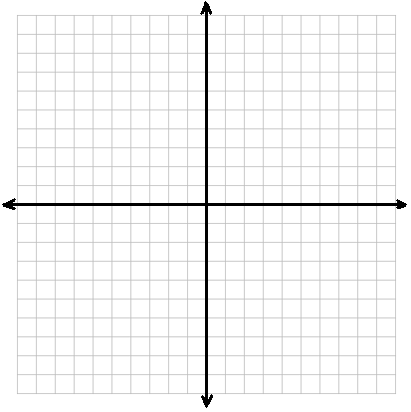 | $f\left(x\right)=\frac{1}{2}{\left(x-1\right)}^{4}$
Real Zero: | Turning Points (aka “the action”):
Based on the definition of “Real Zero”, the following statements are equivalent:

Examples: Creating a Polynomial Function from it’s zeros
- Find a polynomial of degree 3 whose zeros are -3, 2, and 5.  - Use a graphing utility to graph the polynomial function found in part a to verify your result. | - Find a polynomial of degree 4 whose zeros are -2, -1 with a multiplicity of 2, and 1.  - Use a graphing utility to graph the polynomial function found in part a to verify your result.
Multiplicity (or Multiple Root):

If Multiplicity is even: | If Multiplicity is odd:
Behavior Near a Zero: | How to find the Behavior Near a Zero:
End Behavior. For large values of x, either positive or negative, the graph of the polynomial __________________________ resembles the graph of the power function ______________________.
(See Figure 17)

See Example 8

Making the Graph of a Polynomial:
Step 1: Find the _____________________________
Step 2: Determine if the graph will _________________________ or _______________________ at the real zeros.
Step 3: Determine the ______________________________ (recognize which parent function it will look like).
Step 4: Determine ________________________ number of turning Points.
Step 5: Behavior near each _____________________________ **
Step 6: Sketch the graph. Be sure to _______________________.

Table Set up for Polynomial and Rational Function:
Intervals (determined by real roots aka ___________ | #of columns will vary based on the # of Real Roots
X- value (in each interval)
Work: Plug in the x-value
Point on the graph (x,y)
Location: Above or Below the x-axis

Graph the Polynomial Function:  $$f\left(x\right)=x^{3}+x^{2}-12x$$ | Graph the Polynomial Function:  $$f\left(x\right)=x^{2}\left(x-4\right)(x+1)$$
5.2 & 5.3 - Properties of Rational Functions
Rational Functions: Proper Rational Functions:

Improper Rational Functions: Horizontal Asymptote:

Vertical Asymptote: Oblique Asymptote:

**A Rational Function can have one horizontal asymptote or one oblique asymptote OR no horizontal or oblique asymptote.

A rational function will ____________ cross or touch a ______________________ asymptote.
A rational function ________________ cross or touch a ___________________ asymptote.
A rational function ________________ cross or touch a ___________________ asymptote.

“Unbounded in the negative direction”:

Vertical Asymptotes:
Make sure that: _____________________________________________________
The V.A. will occur at the ________________________ of the denominator (meaning the remaining ____________________________________________. Rational functions _________ or __________________ have vertical asymptotes.
Examples:
Horizontal or Oblique asymptotes- 4 different situations
- The ______________________ of the numerator is __________________________ the degree of the denominator. This is a ______________________ rational function. The _____________ is the horizontal asymptote. The equation of the line is ___________________________.

- The __________________________ of the numerator and the denominator are _________ _______________. The __________________________________ is the leading co-efficient of the _______________________________, a, divided by the leading coefficient of the denominator, b. ___________________________

- The degree of the numerator is _________________________ than the degree of the denominator ___________________. The ___________________________________________ is found by dividing the numerator by the denominator. The quotient (after discarding the remainder) is the ___________________________________________. This will be a linear equation ________________________.

- The degree of the numerator is _________________________________ than the degree of the denominator by _____________________________. There is NO ________________________ asymptote and NO ______________________________ asymptote.
Examples:

Math 1050- 5.3 Lecture Notes
Analyzing the Graph of a Rational Function:
Step 1: Find the __________________
Step 2: Write R(x) in ______________________________
Step 3: Locate the _____________________________ in R(x) = P(x)/Q(x).
The ___________________ can be found by solving P(x) = 0 (or set R(x) = 0 and solve).
The ____________________ can be found by _____________________.
Step 4: Find the ___________________________ and calculate the _____________ of the holes.
Step 5: Locate any __________________________________ or ___________________________ asymptotes.
- Let R(x) = _______________________________________ to find ________________________________________________________.
Step 6: Create a _________________________________.
Find values within each _____________________________. Indicating specific _____________ and whether the graph is ____________________ or _______________ the x-axis.
Table Set up for Polynomial and Rational Function:
Intervals (determined by real roots aka ___________ | #of columns will vary based on the # of Real Roots
X- value (in each interval)
Work: Plug in the x-value
Point on the graph (x,y)
Location: Above or Below the x-axis

Step 7: _____________________________________ the graph using ____________________________ gathered from the previous steps.

