Triangle Congruence
Secondary Math II
7.1 Worksheet

Name: _________________________________________________ Date: ____________________________________

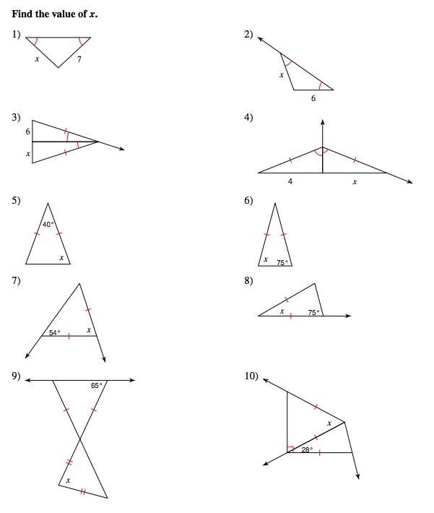

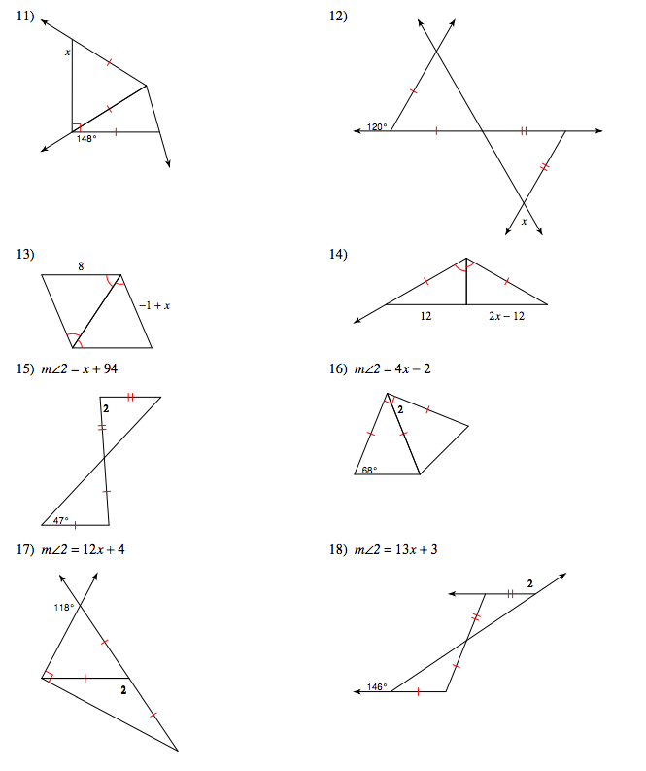

Mark the angles and sides of each pair of triangles to indicate that they are congruent

19) ∆BDC ≅ ∆MLK 20) ∆GFE ≅ ∆LKM
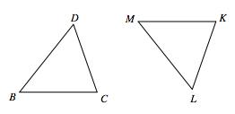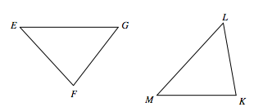

21) ∆MKL ≅ ∆STL 22) ∆HIJ ≅ ∆JTS
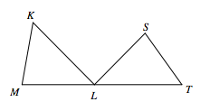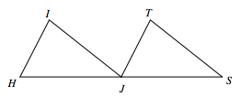

23) ∆CDB ≅ ∆CDL 24) ∆JIK ≅ ∆JCD

