## Secondary Math II – 7.5 Indirect Measurments

## More Practice with Congruence and Similarity

Name___________________________________________ Hour___________

1. Most TV screens have similar shapes. The measure of the diagonal is used to give screen size. Suppose the dimensions of a 9-inch screen are 5.5 inches by 7.5 inches. **Find the dimensions of an 18-inch TV and a 35-inch TV.**
2. A 9 ft tall stop sign casts a 12ft shadow. A building near this stop sign casts a 63ft shadow.
3. How tall is the building?
4. If the distance from the top of the building to the end of the shadow is 87ft, what is the distance from the top of the stop sign to the end of its shadow?

## Ready, Set, Go!

Name___________________________________________________________ Hour____________

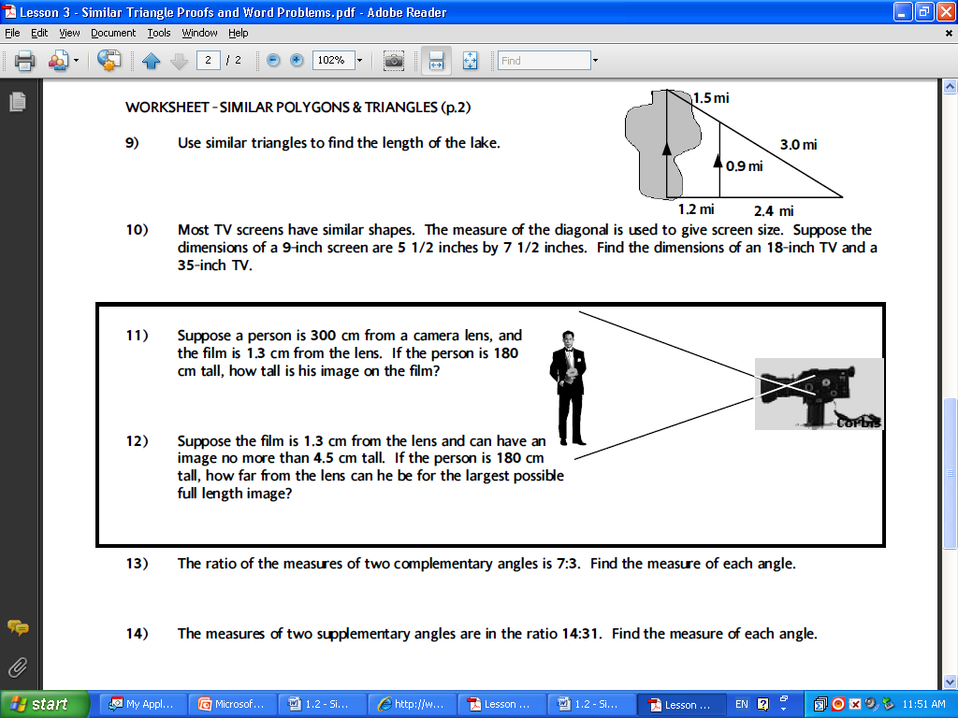**Ready**

1. Find the length of the lake.
2. A Tower casts a shadow of 64 feet. A 6-foot pole near the tower casts a shadow 8 feet long. How tall is the tower?
3. A ladder that is 30ft tall leans 25ft up against the side of a building. Up against the same building, how far up would a 20ft ladder go?



1. The triangles in the figure are similar. Find the value of x.

1. Maria is visiting the Washington Monument in D.C. She wants to know the height of the Monument. The monument’s shadow is 111 feet at the same time that Maria’s shadow is 1 foot Maria is 5 feet tall.

**Set**

1. Sam built a ramp to a loading dock. The ramp has a vertical support 2 meters from the base of the loading dock and 3 meters from the base of the ramp. If the vertical support is 1.2 meters in height, what is the height of the loading dock?
2. Two extension ladders are leaning at the same angle against a vertical wall. The 3-m ladder reaches 2.4 m up the wall. How far up the wall does the 8-m ladder reach?
3. Mr. Smith is having some photos enlarged for his home. He wants to enlarge a photo that is 5 inches by 7 inches so the dimensions are 3 times larger than the original. How many times larger than the original photo will the **area** of the new photo be?
4. Emily is moving and needs to pack two mirrors. The largest mirror fits in a box that is 18 inches by 20 inches long. Her smaller mirror is similar in proportion to the larger mirror. Emily determines that the width of the smaller box needs to be a minimum of 9 inches. What should the minimum length of the box be to hold the smaller mirror?

**Go!**

*For # 10 and 11 A) find the measurement and B) explain how you know the triangles are similar. Circle your answers.*

1. A flagpole casts a shadow 48 feet long at the same time that a 6 foot tall person casts a shadow 24 feet long. How tall is the flagpole?

A)

h



6’

24’

48’



B)

1. What is the distance of AB across the lake?

A)

B)

Lake

A

B

50 m

50 m

P

25 m

D

15 m

C

25 m